|  |
| --- |
| Name: ________________________________ Date: _________  **Problem Set** for lesson 52 Geometry |



For 1 – 4 solve for x.

|  |  |
| --- | --- |
| 1. | 2. |
| 3. | 4. |

1. Find the midpoint of the line segment with the endpoints (5, 2) and (-4, -3)
2. 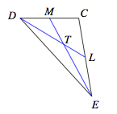EM and DL are medians. Find x if ET = 3x + 2 and EM = 5x.
3. Given: , diagonal 



Prove: 