|  |
| --- |
| Name: ________________________________ Date: _________  **Problem Set** for lesson 50 Geometry |



1. 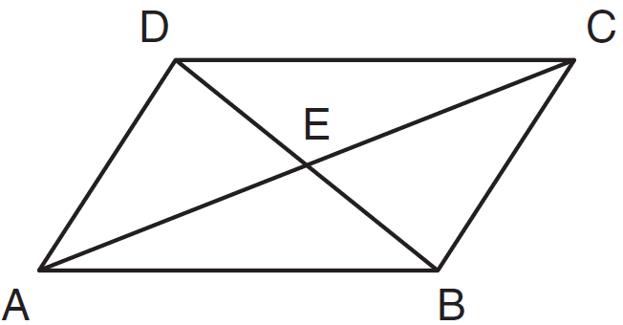In the diagram  has diagonals  and  that intersect at E.

Which expression is *not* always true?

1.  (3) 
2.  (4) 
3. In   and . Find .
4. What is the measure of each interior angle of a regular 16-sided polygon?



1. In , , , 

and . Find the value of *x* and *y.*

Find the length of AB, BC, CD and DA.